

**Product Dissection for Meesho**

### **Company Overview:**

Meesho, established in 2015 by Vidit Aatrey and Sanjeev Barnwal, completely transformed the online shopping experience. It's a fantastic platform that lets individuals effortlessly buy and sell a variety of products. Meesho is well-known for its easy-to-use interface and innovative features, making it a top player in online shopping. The platform encourages a community-driven way of doing business. By focusing on making it simple for people to connect and trade, Meesho has built a large user community. This has firmly established Meesho as a major player in the online marketplace

### **Product Dissection and Real-World Problems Solved by Meesho:**

Meesho, an innovative e-commerce platform, has effectively addressed real-world challenges by providing a unique solution to empower individuals, particularly micro-entrepreneurs and small businesses, to start and grow their online businesses. Meesho's platform focuses on social commerce, allowing users to discover, share, and sell a diverse range of products directly through social media channels. This approach addresses the challenge of limited access to markets for small businesses, enabling them to reach a wider audience and establish a digital presence.

Meesho's key feature lies in its simplicity and accessibility. The platform provides users with a user-friendly interface, making it easy for sellers to create an online store, showcase products, and manage transactions. This addresses the real-world problem of technological barriers and lack of online selling expertise, empowering individuals with limited resources to participate in e-commerce.

Furthermore, Meesho leverages the power of social connections by integrating sharing and networking functionalities. Sellers can easily share product catalogs with their network on social media platforms, enabling them to leverage existing relationships and build trust with potential customers. This innovative approach addresses the challenge of customer acquisition for small businesses, providing a cost-effective and efficient way to reach and engage with their target audience.

Meesho's platform also incorporates features like order tracking, secure payment options, and customer support, addressing concerns related to the reliability and security of online transactions. By providing a comprehensive solution for both sellers and buyers, Meesho contributes to building a trustworthy and efficient social commerce ecosystem.

In conclusion, Meesho's product design effectively solves real-world problems by democratizing e-commerce, enabling individuals to embrace entrepreneurship, connect with a broader audience, and overcome traditional barriers to entry in the online marketplace. Through its emphasis on social commerce, accessibility, and community building, Meesho provides a practical and inclusive solution to the evolving needs of micro-entrepreneurs in the digital era.

### **Case Study: Real-World Challenges and Meesho's Tailored Solutions**

Meesho, a groundbreaking social commerce platform, not only reshapes online interactions but proactively tackles real-world challenges through innovative features. By aligning with user needs and leveraging cutting-edge technology, Meesho stands as a platform that fosters connections while providing bespoke solutions to prevailing issues in the digital landscape.

**Problem 1: Accessible Entrepreneurship**

**Real-World Issue:** Many aspiring entrepreneurs face barriers to entry in the digital marketplace, limiting their ability to start and scale their businesses.

**Meesho's Solution:**

Recognizing the need for accessible entrepreneurship, Meesho empowers individuals to start their online businesses with minimal investment. Through a user-friendly interface and comprehensive seller support, Meesho provides a platform where anyone can become a micro-entrepreneur, curating their online store and connecting with a vast network of potential customers. This solution addresses the challenge of entry barriers, fostering a culture of entrepreneurship.

**Problem 2: Localized Commerce in a Global Market**

**Real-World Issue:** Amidst globalization, small businesses struggle to maintain a local identity and appeal to a global audience.

**Meesho's Solution:**

Meesho introduces a localized approach to global commerce. By enabling sellers to customize their storefronts and tailor their offerings to local preferences, Meesho ensures that small businesses can maintain their unique identity while accessing a global customer base. This solution navigates the challenge of balancing local authenticity with global reach, providing businesses with the tools to thrive in diverse markets.

**Problem 3: Building Trust in Online Transactions**

**Real-World Issue:** Users often hesitate to engage in online transactions due to concerns about trust and reliability.

**Meesho's Solution:**

Meesho prioritizes building trust in online transactions through its secure and transparent platform. By implementing robust buyer protection policies, transparent seller ratings, and a seamless return process, Meesho ensures a trustworthy and reliable online shopping experience. This solution addresses the challenge of building confidence in users engaging in online transactions, fostering a secure and trustworthy marketplace.

**Problem 4: Sustainable Commerce Practices**

**Real-World Issue:** The environmental impact of e-commerce is a growing concern, and users seek platforms that prioritize sustainable practices.

**Meesho's Solution:**

Meesho takes a stand for sustainable commerce by promoting eco-friendly and ethically sourced products. The platform encourages sellers to adopt sustainable practices, reducing the environmental footprint of online commerce. Meesho's commitment to sustainability addresses the challenge of aligning consumer values with shopping choices, providing a platform where users can make environmentally conscious purchasing decisions.

**Problem 5: Facilitating Peer-to-Peer Transactions**

Real-World Issue: Users encounter difficulties in facilitating peer-to-peer transactions securely and efficiently.

**Meesho's Solution:**

Meesho extends its commitment to user convenience by introducing seamless peer-to-peer transactions within the platform. Through a secure and user-friendly interface, Meesho allows users to engage in peer-to-peer transactions, fostering a community-driven marketplace. This solution addresses the challenge of enabling secure and efficient peer-to-peer transactions, providing users with a comprehensive platform for both business and personal transactions.

**Conclusion:**

Meesho's evolution into a global social commerce leader reflects its dedication to understanding and solving real-world challenges. By empowering entrepreneurs, embracing localized commerce, building trust in online transactions, championing sustainability, and facilitating peer-to-peer transactions, Meesho continues to shape the digital landscape. This case study illustrates how Meesho's tailored solutions contribute to its success, offering users a platform that goes beyond conventional social commerce by addressing unique challenges in today's dynamic market.

### **Key Features of Meesho:**

1. **Reseller Profiles:** Meesho empowers individuals to establish their unique reseller profiles. Users can showcase their entrepreneurial journey with profile details, business names, bios, and profile pictures, creating a personalized online identity that reflects their brand.
2. **Product Listings:** At the core of Meesho is the ability to curate and share product listings. Resellers can showcase a diverse range of products, complete with descriptions, pricing, and appealing images. This feature enables them to effectively market and sell items to their network.
3. **Engagement Tools:** Interactions are fundamental to success on Meesho. Resellers can engage with customers through comments, private messages, and reactions. The platform also offers tools to promote customer engagement, such as personalized recommendations and exclusive deals.
4. **Order Management:** Meesho streamlines the order management process for resellers. They can easily track orders, manage inventory, and stay organized through the app. This feature ensures a smooth and efficient workflow for reselling businesses.
5. **Customer Network:** Building connections is key on Meesho. The "Connect" functionality allows resellers to expand their customer network by connecting with other resellers. Additionally, they can view and manage their customer base, fostering transparency and trust.
6. **Trending Products:** The "Discover" feature on Meesho suggests trending and popular products based on reseller preferences and market trends. This enhances the reselling experience by providing insights into what products are currently in demand, helping resellers stay ahead in their business.

### **Schema Description:**

Meesho, a leading social commerce platform, operates through a well-structured schema involving various entities that cater to different facets of the platform. These entities are tailored to provide an efficient and engaging experience for resellers and customers alike. Here are the key entities and their attributes within the Meesho schema:

**Reseller Entity:**

Resellers are central to the Meesho platform. The reseller entity encompasses crucial information about each reseller:

* **ResellerID (Primary Key):** A unique identifier for each reseller.
* **Profile_Name:** The chosen profile name for the reseller's account.
* **Email:** The reseller's email address for communication and order-related updates.
* **Full_Name:** The full name of the reseller as displayed on their profile.
* **About_Me:** A brief description that resellers can use to showcase their expertise and offerings.
* **Registration_Date:** The date when the reseller joined Meesho.

**Product Entity:**

Products showcase the diverse range available on the platform:

* **ProductID (Primary Key):** A unique identifier for each product.
* **ResellerID (Foreign Key referencing Reseller Entity):** The reseller who listed the product.
* **Product_Title:** Descriptive title for the product.
* **Image_URL:** The URL of the product image.
* **Category:** The categorized section under which the product is listed.
* **Price:** The cost of the product.

**Engagement Tool Entity:**

Engagement tools empower resellers to connect with their audience:

* **ToolID (Primary Key):** A unique identifier for each engagement tool.
* **ResellerID (Foreign Key referencing Reseller Entity):** The reseller utilizing the tool.
* **Tool_Type:** The type of engagement tool, such as promotions, discounts, or campaigns.
* **Description:** Information describing the purpose and details of the engagement tool.
* **Engagement_Date:** The date when the engagement tool was initiated.

**Order Management Entity:**

Efficient order management ensures a smooth transaction process:

* **OrderID (Primary Key):** A unique identifier for each order.
* **ResellerID (Foreign Key referencing Reseller Entity):** The reseller managing the order.
* **ProductID (Foreign Key referencing Product Entity):** The product included in the order.
* **Quantity:** The quantity of the product ordered.
* **Order_Date:** The date when the order was placed.

**Customer Network Entity:**

Building a network of customers is key to Meesho's success:

* **NetworkID (Primary Key):** A unique identifier for each customer network relationship.
* **ResellerID (Foreign Key referencing Reseller Entity):** The reseller initiating the customer connection.
* **CustomerID (Foreign Key referencing Reseller Entity):** The customer being connected.
* **Connection_Date:** The date when the customer network relationship was established.

**Trending Products Entity:**

Highlighting popular and trending products on the platform:

* **TrendID (Primary Key):** A unique identifier for each trending product.
* **ProductID (Foreign Key referencing Product Entity):** The product that is currently trending.
* **Trend_Start_Date:** The date when the product started trending.

**Relationships are:**

* **Resellers List Products –** Each reseller can list multiple products on the Meesho platform, and each product is listed by a specific reseller.
* **Resellers Utilize Engagement Tools –** Resellers can utilize various engagement tools to connect with their audience, and each engagement tool is associated with a specific reseller.
* **Resellers Manage Orders –** Resellers manage multiple orders on the platform, and each order is managed by a specific reseller.
* **Resellers Build Customer Networks –** Resellers build networks with multiple customers, and each customer is part of a network initiated by a specific reseller.
* **Products Belong to Categories –** Many products can belong to one category, but each product is associated with only one category.
* **Products are Trending –** Each product may have zero or one corresponding trending entry, and each trending entry is associated with exactly one product.

**ER Diagram:**

Let's construct an ER diagram that vividly portrays the relationships and attributes of the entities within the Meesho schema. This ER diagram will serve as a visual representation, shedding light on the pivotal components of Meesho's data model. By employing this diagram, you'll gain a clearer understanding of the intricate interactions and connections that define the platform's dynamics.

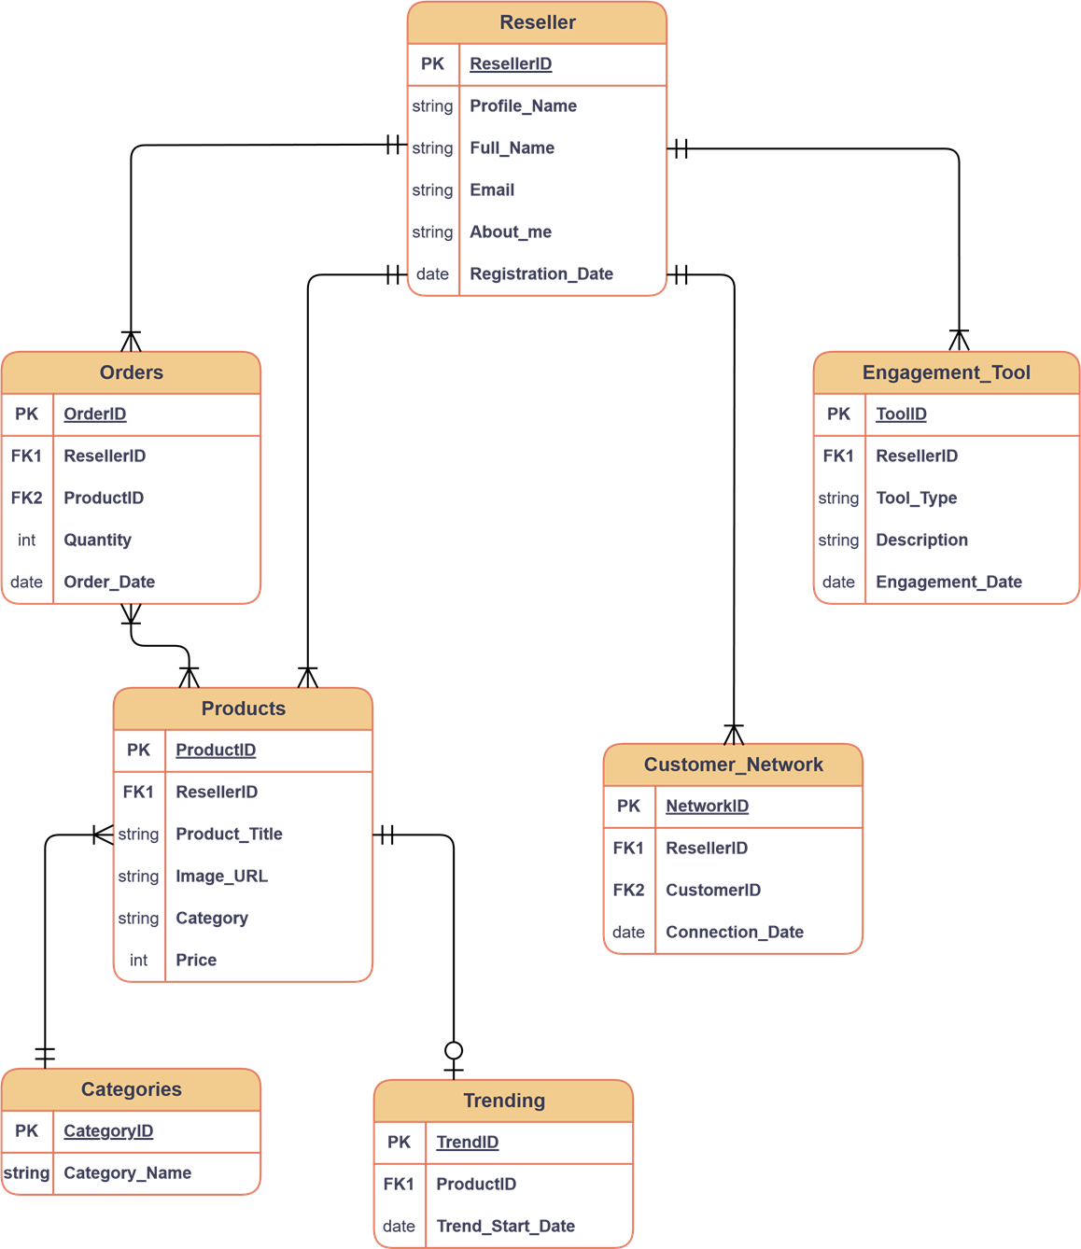

### **Conclusion:**

In this case study, we delved into the structure of Meesho's schema and Entity-Relationship diagram. Meesho has transformed social commerce, changing how people connect and engage in online shopping. The platform's intricate data model, including sellers, products, orders, customers, payments, and connections, lays the foundation for its smooth operations. Understanding this schema gives us insights into how Meesho effectively handles user transactions and product interactions, contributing to its widespread success and continued growth in social commerce.